**1.1 Introduction**

This Taxi Mobile App is a modern-day tool to solve our day to day transportation related problems. There are a number of issues when it comes to travelling from one place to another.

Some people don't have their own vehicles, and others don't want to use public transport like buses to travel, independent taxi owners asking for higher fares and many more.

Far such problems businesses need a mobile extension of their services, With the advent of technology and the features provided by mobile applications and devices, the mobile platform provides location-based services, variety of payment platforms and ease of use, we have thought of a mobile application to hire a taxi and commute.

The app aims to provide solution to these issues by providing ease to book cheaper and more pleasant taxi rides to anyone with access to a smartphone with internet connection, allowing customer to choose a taxi of their choice from list of available anytime when they want to.

The app will encourage both customers in need of ride as well as taxi owners and taxi service provider to register with the app, thus diminishing the distance between customers and taxi owners.

Customer can request a ride and driver will be able to accept based on the details, such as pickup location of the passenger, distance and time required to reach the destination.

Passenger and driver will be able to chat and call in case of need before the taxi reaching to the customer, they will be able to be in touch.

The app will display the fare of the ride and will help customer to receive discount and coupons based on history of their rides which were made using this app.

There will be a driver app which will allow the driver to see the details of the ride such as distance and time and choose whether wants to take passenger or not.

Admin of the app will be able to see the details of the driver and passenger, send promotional messages to the customers.

**1.2. Limitations of Existing System**

1. No coupons and discount options.
2. No location of nearby drivers.

**1.3. Feature**

1. **Number of Apps: There will be 2 Apps namely**
2. Customer app
3. Driver app
4. **Data Storage: Stores data**
5. MySQL database
6. **User registration : User and driver registration**
7. User registration
8. Phone number is required
9. Name and Last name
10. Password is required
11. optional email id
12. Driver Registration

Done by admin

1. request for registration
2. admin will request for details and documents
3. Car details (photos, type, number plate, model)
4. Driver details and IDs (driving license)
5. Recovery options (forgot password)
6. update profile of both driver and customer
7. **Book my ride : Customer can book his ride**
8. Choose pickup and destination location
9. search for location
10. Car selection
11. Call/Chat with driver
12. provide user the model car, number plate and details of driver with photos
13. live driver location
14. Travel cost calculation based on distance and duration
15. **Car categories : Different types of cars**
16. types
17. models
18. pricing based on car type
19. **Calling and chat : Customer and driver can call and chat**
20. phone number of driver and customer
21. **Payment : Can do payment through cash or debit**
22. payment using credit/debit card
23. cash payment
24. **Promotions : Type of Coupons code**
25. coupons
26. share app credits
27. discount on special occasions
28. promotions send to customer
29. **Reviews : Can review about driver and rider**
30. Review driver.
31. Review taxi.
32. **History of Rides:Shows all recent rides**
33. all travel details with locations and prices

**1.4.Project Specification**

1. The app will be for both Android and iOS platforms.
2. There will be two app driver and customer app.
3. Driver registration through admin.
4. Customer registration will be made using mobile number.
5. Mobile number serves as the main id for user identification.
6. First list of cars will be shown to user then nearby drivers.
7. Selected car number plate, model and photo will be sent to user.
8. Currency type.
9. Cost calculation based on kilometres and in case of heavy traffic there will be extra charges.
10. Distance and time will be calculated using Google map API.
11. Account recovery will be made through mobile number.
12. After some specific number of travels user will receive coupons to get discount.
13. User will receive points for sharing the app to friends.
14. There will be some amount of discount on special occasions.
15. Promotion emails and SMS will be sent to the customers.
16. Customer will be able to pay using debit/credit card or cash.

**2.1. Entity Relationship Diagram**

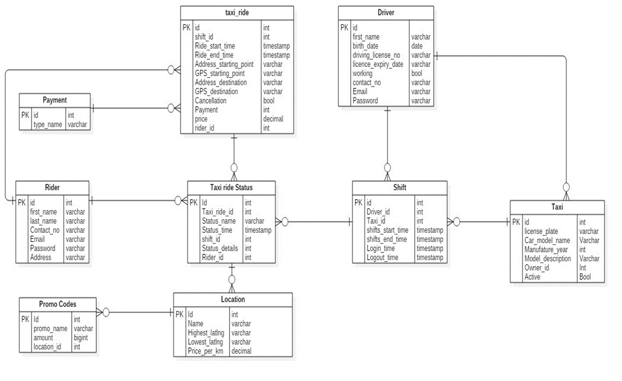

**2.2. Database Schema**

1. **Driver**

|  |  |  |  |  |
| --- | --- | --- | --- | --- |
| **Field** | **Type** | **Null** | **Key** | **Default** |
| id | int | No | Primary | NULL |
| first\_name | Varchar | Yes |  | NULL |
| last\_name | Varchar | Yes |  | NULL |
| birth\_date | date | Yes |  | NULL |
| driving\_license\_no | Varchar | Yes |  | NULL |
| licence\_expiry\_date | Varchar | Yes |  | NULL |
| working | bool | Yes |  | NULL |
| contact\_no | Varchar | Yes |  | NULL |
| Email | Varchar | Yes |  | NULL |
| Password | Varchar | Yes |  | NULL |

**2) Promo code**

|  |  |  |  |  |
| --- | --- | --- | --- | --- |
| **Field** | **Type** | **Null** | **Key** | **Default** |
| Id | Int | No | Primary | NULL |
| Promo name | Varchar | Yes |  | NULL |
| Amount | Bigint | Yes |  | NULL |
| Location\_id | Int | No | Foreign | NULL |

**3) Rider**

|  |  |  |  |  |
| --- | --- | --- | --- | --- |
| **Field** | **Type** | **Null** | **Key** | **Default** |
| Id | Int | No | Primary | NULL |
| first\_name | Varchar | Yes |  | NULL |
| Last\_name | Varchar | Yes |  | NULL |
| Contact\_no | Varchar | Yes |  | NULL |
| Address | Varchar | Yes |  | NULL |
| Email | Varchar | Yes |  | NULL |
| Password | Varchar | Yes |  | NULL |

**4) Location**

|  |  |  |  |  |
| --- | --- | --- | --- | --- |
| **Field** | **Type** | **Null** | **Key** | **Default** |
| Id | Int | No | Primary | NULL |
| Name | Varchar | Yes |  | NULL |
| Highest\_latlng | Varchar | Yes |  | NULL |
| Lowest\_latlng | Varchar | Yes |  | NULL |
| Price\_per\_km | Decimal | Yes |  | NULL |

**5) Payment Type**

|  |  |  |  |  |
| --- | --- | --- | --- | --- |
| **Field** | **Type** | **Null** | **Key** | **Default** |
| Id | Int | No | Primary | NULL |
| Type name | Varchar | Yes |  | NULL |

**6) Taxi Ride Status**

|  |  |  |  |  |
| --- | --- | --- | --- | --- |
| **Field** | **Type** | **Null** | **Key** | **Default** |
| Id | Int | No | Primary | NULL |
| Taxi\_ride\_id | Int | No | Foreign | NULL |
| Status\_name | Varchar | Yes |  | NULL |
| Status\_time | Timestamp | Yes |  | NULL |
| shift\_id | int | No | Foreign | NULL |
| Status\_details | Varchar | Yes |  | NULL |
| Rider\_id | Int | No | Foreign | NULL |

**7)Shifts**

|  |  |  |  |  |
| --- | --- | --- | --- | --- |
| **Field** | **Type** | **Null** | **Key** | **Default** |
| Id | Int | No | Primary | NULL |
| Driver\_id | Int | No | Foreign | NULL |
| Taxi\_id | Int | No | Foreign | NULL |
| shifts\_start\_time | Timestamp | Yes |  | NULL |
| shifts\_end\_time | Timestamp | Yes |  | NULL |
| Login\_time | Timestamp | Yes |  | NULL |
| Logout\_time | timestamp | Yes |  | NULL |

**8) Taxi**

|  |  |  |  |  |
| --- | --- | --- | --- | --- |
| **Field** | **Type** | **Null** | **Key** | **Default** |
| Id | Int | No | Primary | NULL |
| License\_plate | Varchar | Yes |  | NULL |
| Car\_model\_name | Varchar | Yes |  | NULL |
| Manufature\_year | Int(4) | Yes |  | NULL |
| Model\_description | Varchar | Yes |  | NULL |
| Owner\_id | Int | No | Foreign | NULL |
| Active | Bool | Yes |  | NULL |

9) **Taxi Ride**

|  |  |  |  |  |
| --- | --- | --- | --- | --- |
| **Field** | **Type** | **Null** | **Key** | **Default** |
| Id | Int | No | Primary | NULL |
| shift\_id | int | No | Foreign | NULL |
| Ride\_start\_time | Timestamp | Yes |  | NULL |
| Ride\_end\_time | Timestamp | Yes |  | NULL |
| Address\_starting\_point | Varchar | Yes |  | NULL |
| GPS\_starting\_point | Varchar | Yes |  | NULL |
| Address\_destination | Varchar | Yes |  | NULL |
| GPS\_destination | Varchar | Yes |  | NULL |
| Cancellation | Bool | Yes |  | NULL |
| Payment | Int | No | Foreign | NULL |
| Price | Decimal | Yes |  | NULL |
| Rider\_id | Int | No | Foreign | NULL |

**2.2. Activity Diagram**

**A) Rider**

**1. Login**

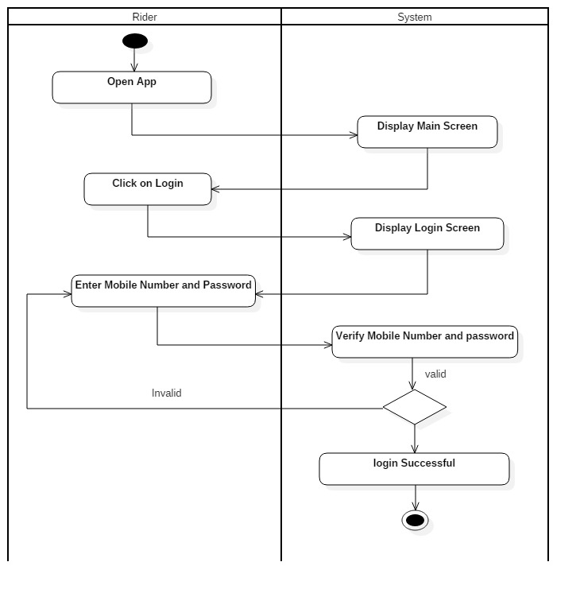

**2. Signup**

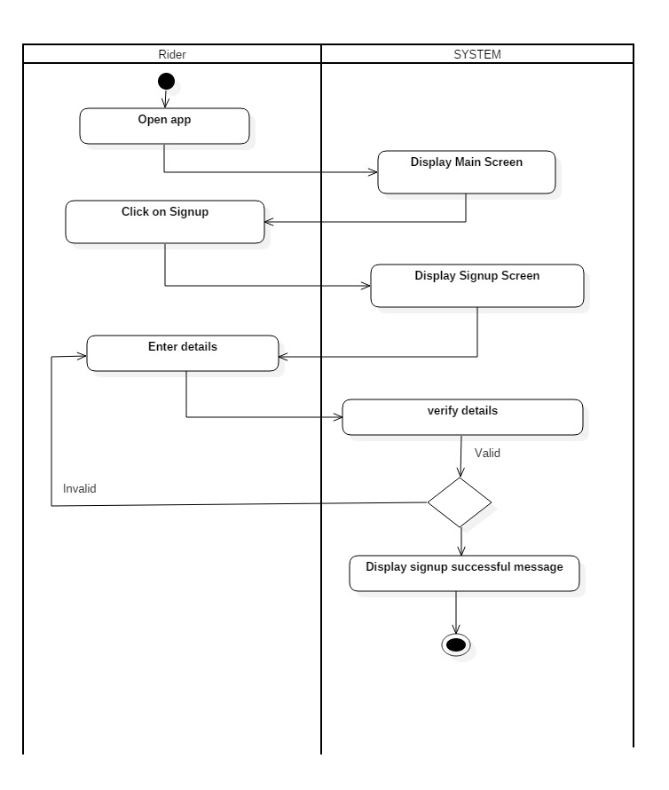

**3. Source and Destination**

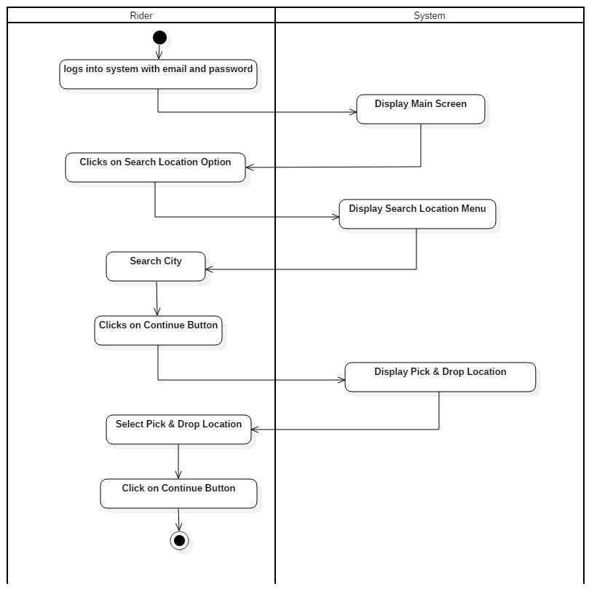

**4. Car Selection**

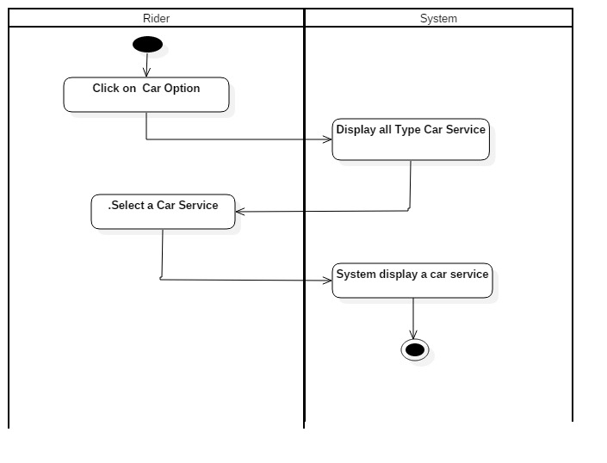

**5. Promo Selection**

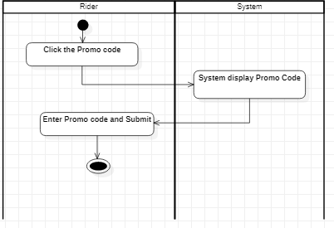

**6. Payment Selection**

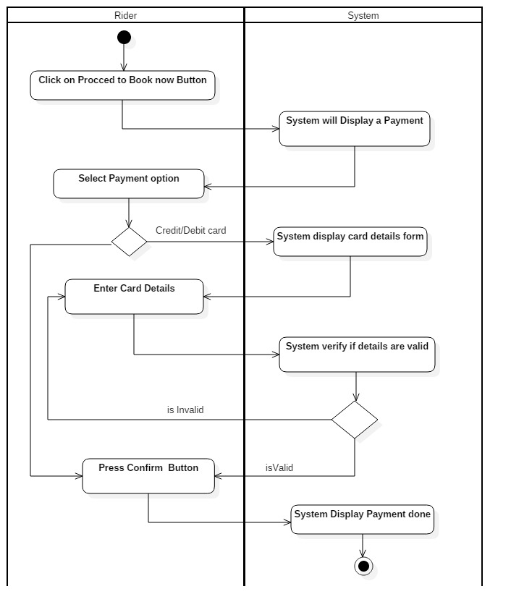

**7. Account Recovery (Forget Password)**

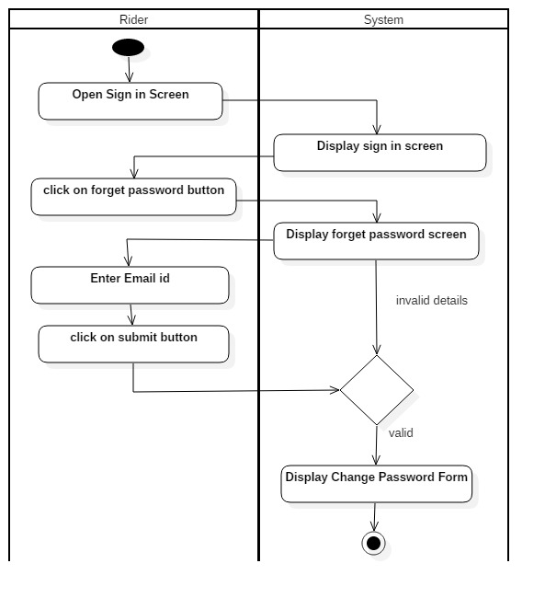

**8. Account Details**

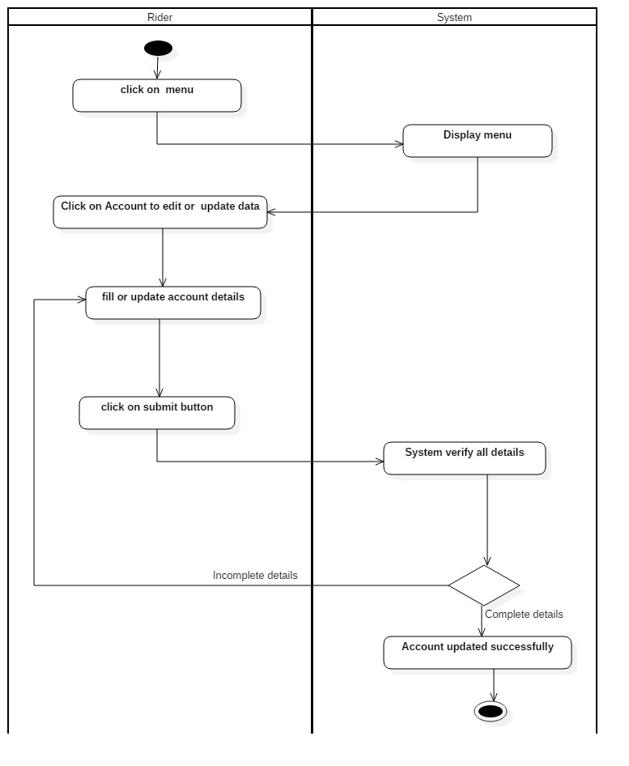

**9. View History**

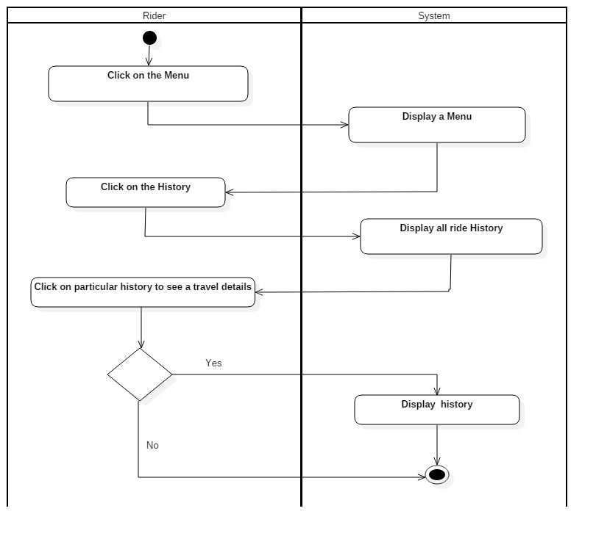

**10. Review**

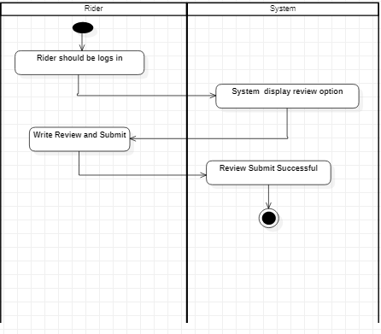

**11. Call Driver**

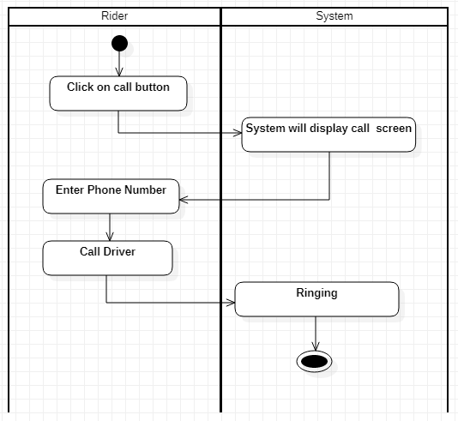

**12. Logout**

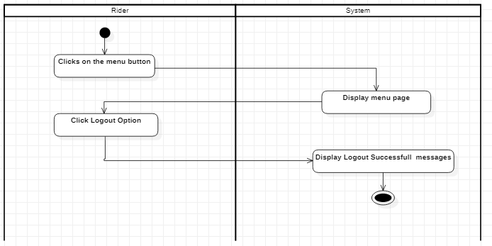

**B) Driver**

1. **Login**

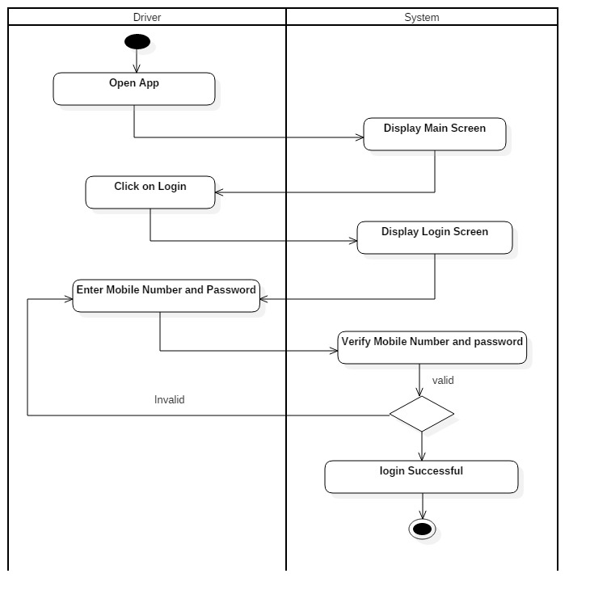

1. **Signup**

**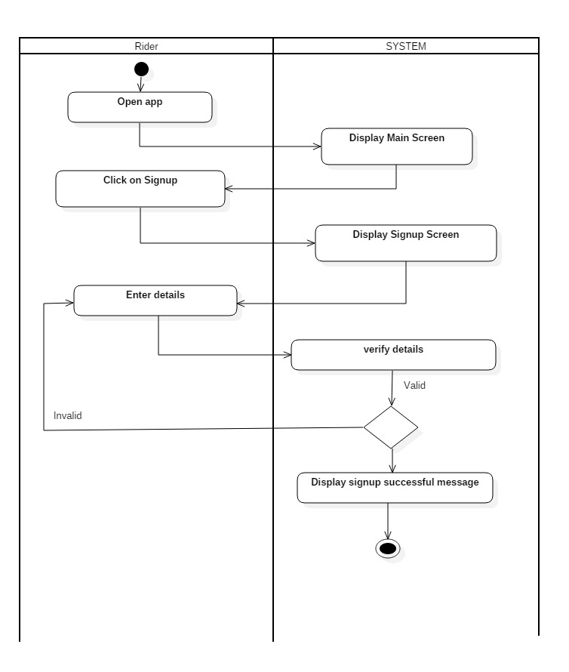**

**3.Account Details**

**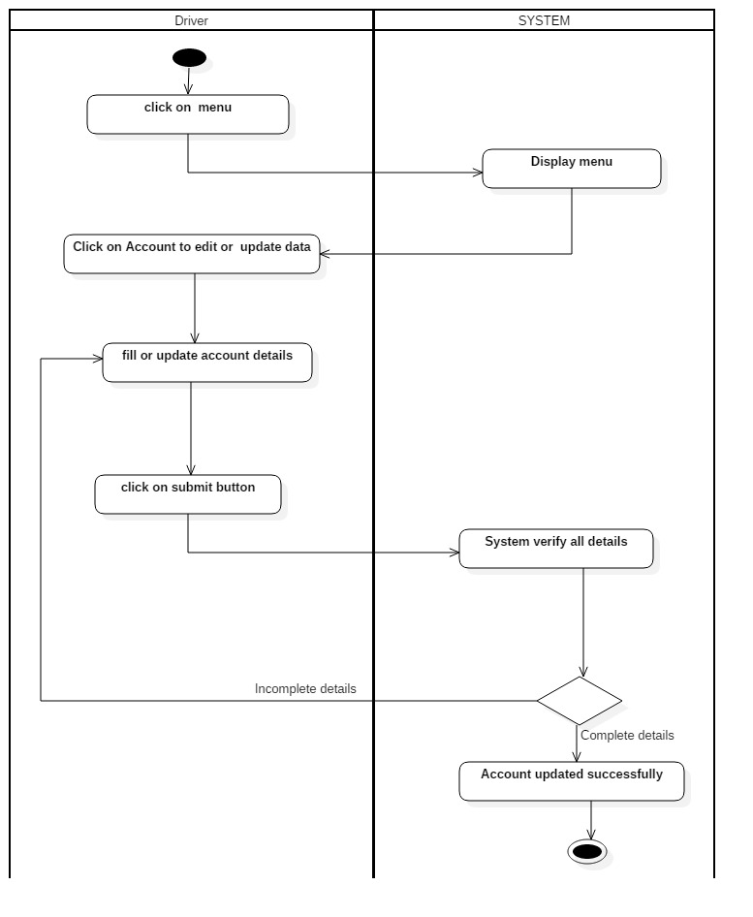**

**4. Account Recovery (Forget Password)**

**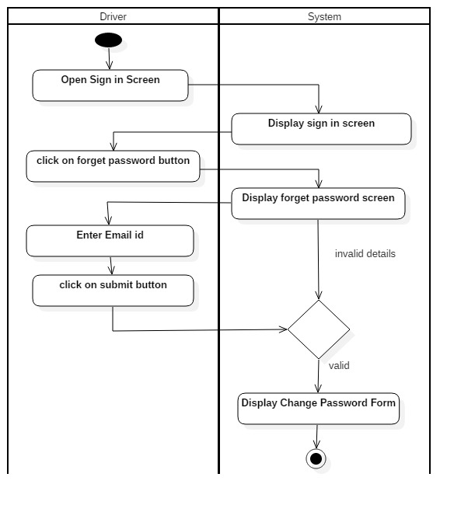**

**5. Submit Details**

**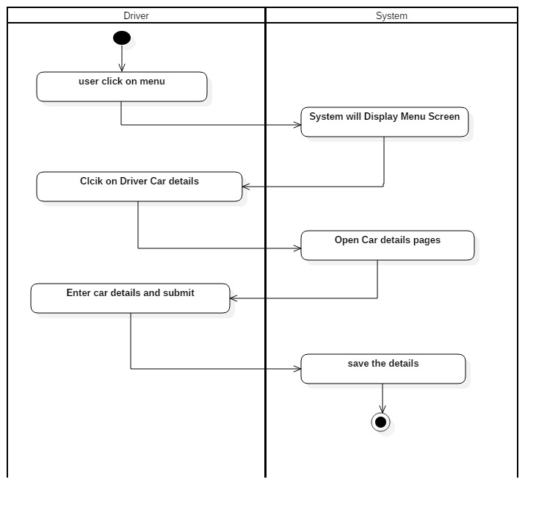**

**6. Select a Ride**

**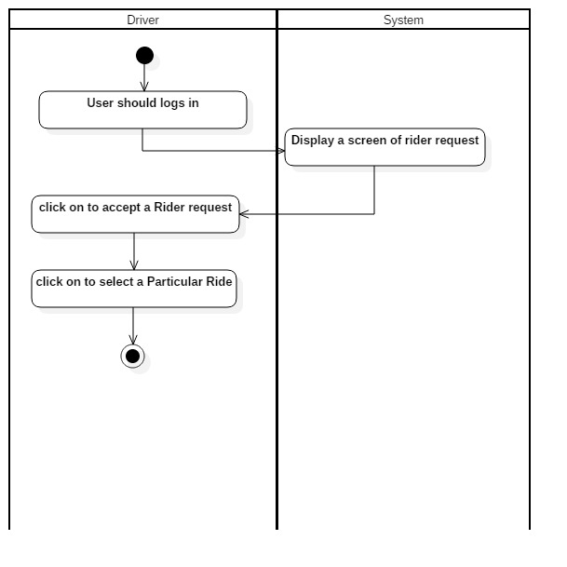**

**7. Available/Unavailable (Request Customer)**

**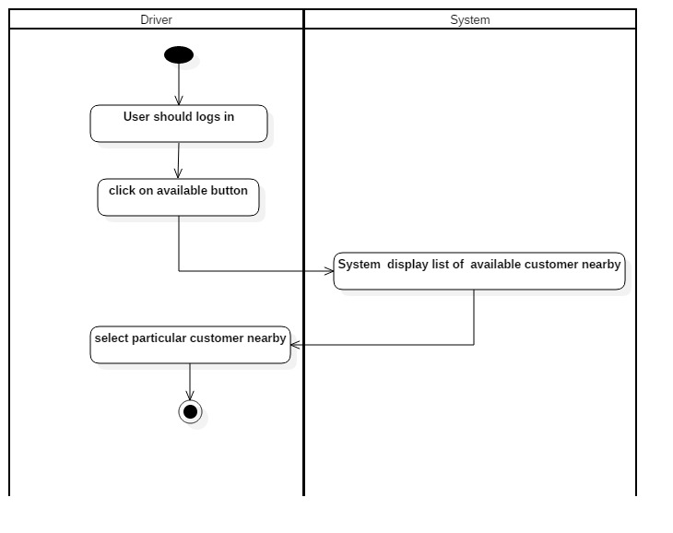**

**8. View History**

**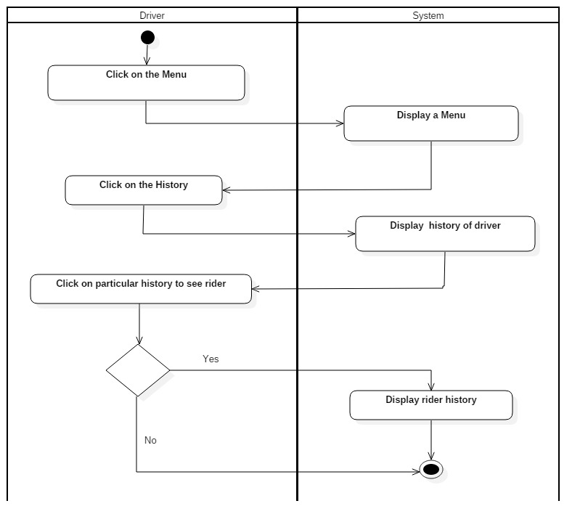**

**9. Logout**

**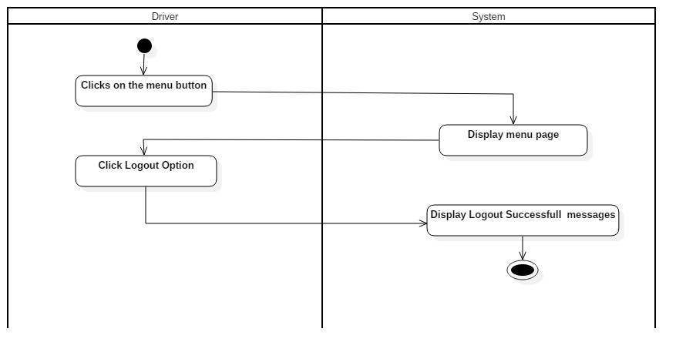**

**C. Admin**

**1. Login**

**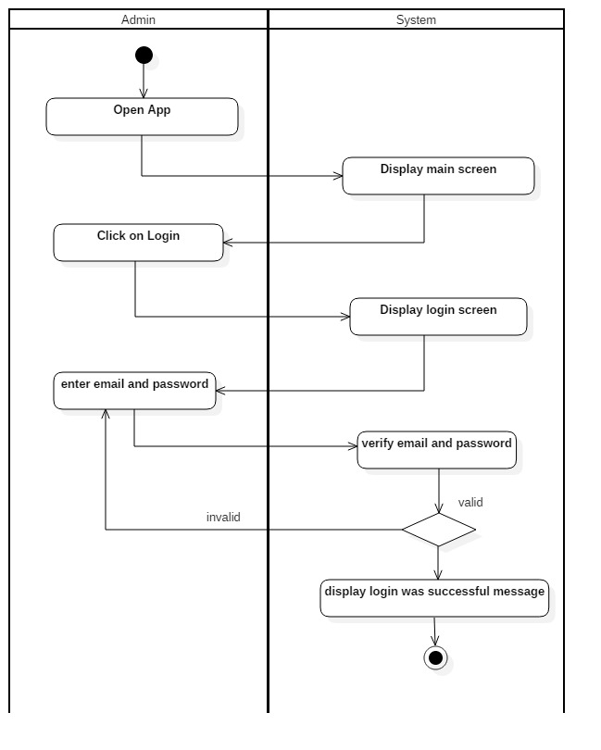**

**2. Verify driver**

**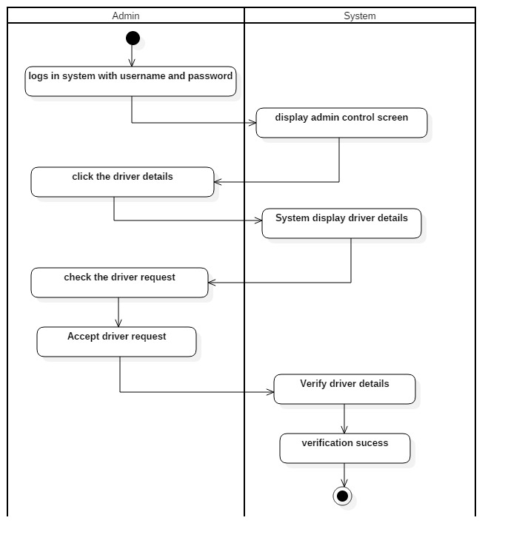**

**3. Rider details**

**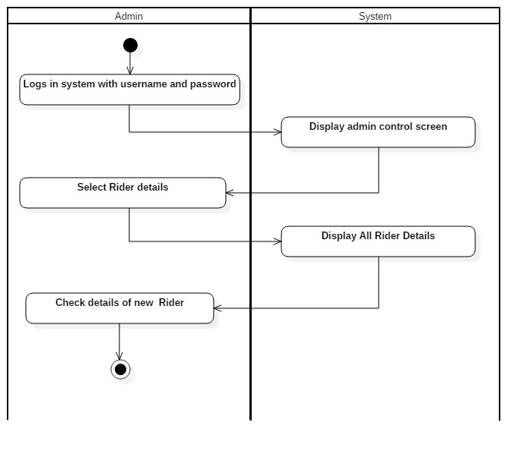**

**4. Driver details**

**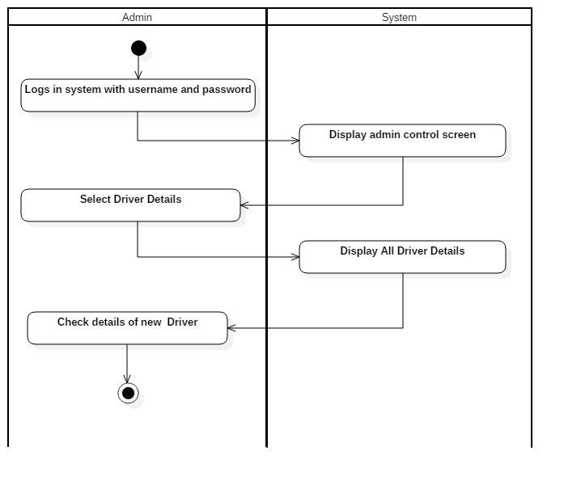**

**5. Create promo**

**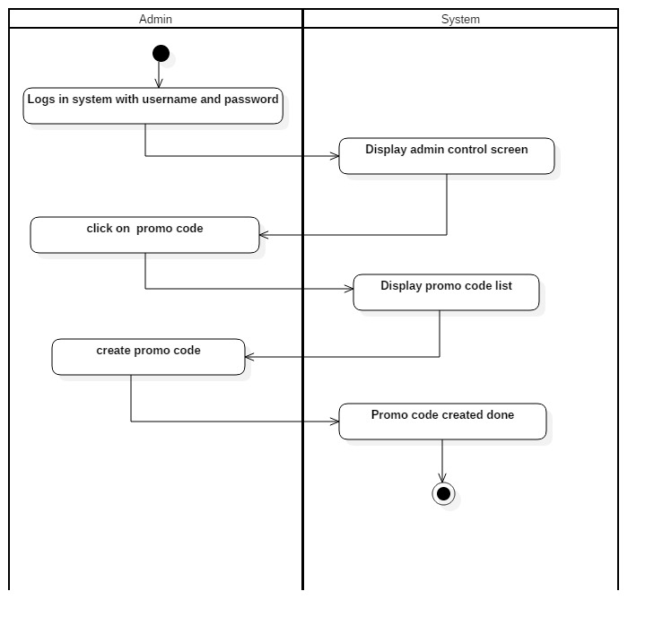**

**6. Car list**

**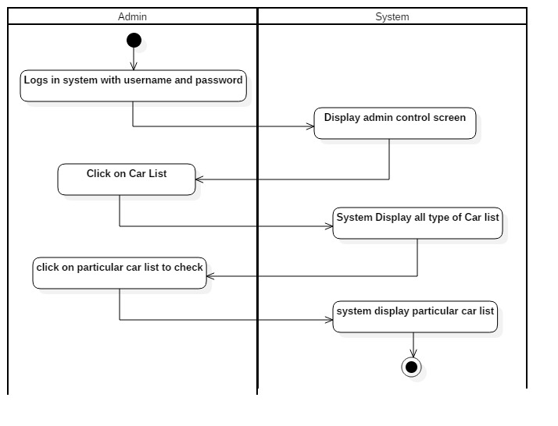**

**2.3. Use Case Diagram**

**A) Rider**

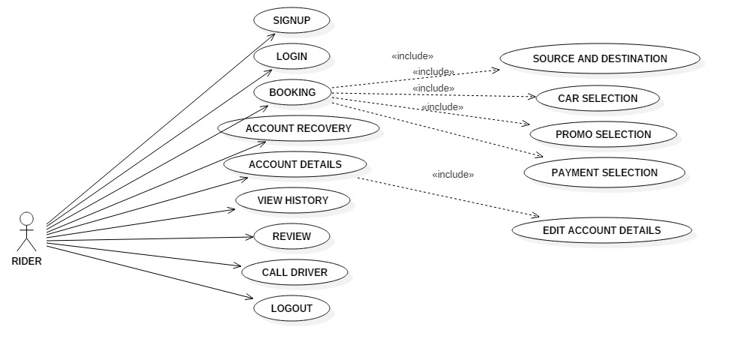

**B) Driver**

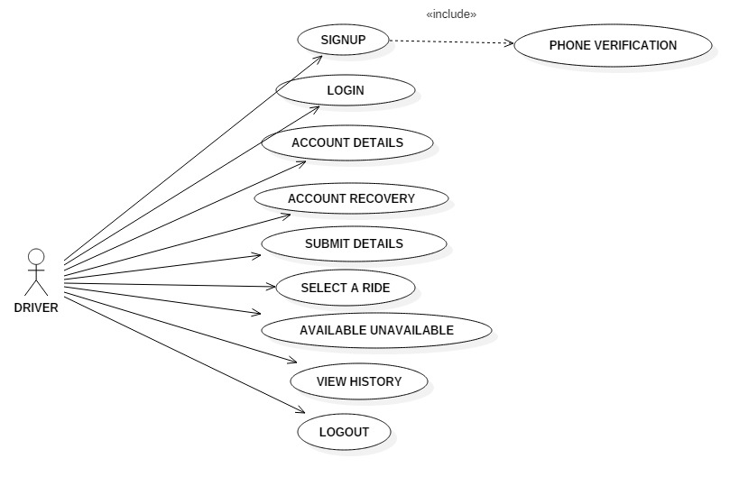

**C. Admin**

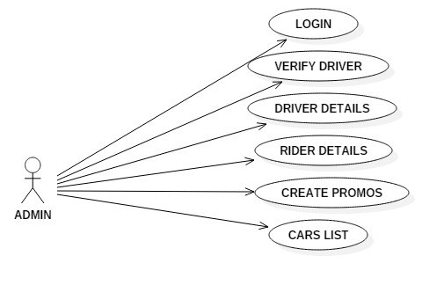

**2.5. Detailed Use Cases**

**A) Rider**

1. **Login**

|  |  |
| --- | --- |
| **Use Case Name** | **Login** |
| Scope | My Taxi-Taxi Booking Mobile Application |
| Level | User Goal |
| Primary Actor | Rider |
| Stack Holder & Interest | Rider want to Login |
| Precondition | Rider Phone-Number and Passowrd |
| Post-Condition | Successful Login |
| Main Screen Scenario | 1. Open Login Page 2. Enter Phone Number and Passowrd 3. Click on Login Page |
| Extension | Invalid Phone-Number |

1. **Signup**

|  |  |
| --- | --- |
| **Use Case Name** | **Sign-up** |
| Scope | My Taxi-Taxi Booking Mobile Application |
| Level | User Goal |
| Primary Actor | Rider |
| Stack Holder & Interest | Rider want to Sign-up to the app |
| Precondition | Rider Email ,Phone Number, First Name, Last Name, Password |
| Post-Condition | Signup Successful Message |
| Main Screen Scenario | 1. Open Sign Up 2. Enter Phone Number,Email,Password, First Name, Last Name 3. Click on Signup button |
| Extension | 1.Empty Fields  2. Invalid details |

1. **Source & Destination**

|  |  |
| --- | --- |
| **Use Case Name** | **Source & Destination** |
| Scope | My Taxi-Taxi Booking Mobile Application |
| Level | User Goal |
| Primary Actor | Rider |
| Stack Holder & Interest | Rider want to select source and destination |
| Precondition | Rider |
| Post-Condition | Continue Button |
| Main Screen Scenario | 1. Clicks on Search Location Option 2. Display Search Location Menu 3. Search city 4. Click on continue 5. Display Source and Destination 6. Select Source and Destination 7. Click on Continue Button |
| Extension |  |

1. **Car Selection**

|  |  |
| --- | --- |
| **Use Case Name** | **Car Selection** |
| Scope | My Taxi-Taxi Booking Mobile Application |
| Level | User Goal |
| Primary Actor | Rider |
| Stack Holder & Interest | Rider want to select a car |
| Precondition | Rider choose a car |
| Post-Condition | Click on next page |
| Main Screen Scenario | 1. Click on Select car button 2. System will Display Car Option 3. Select a Particular Car 4. System will display a car |
| Extension |  |

1. **Promo Selection**

|  |  |
| --- | --- |
| **Use Case Name** | **Promo Selection** |
| Scope | My Taxi-Taxi Booking Mobile Application |
| Level | User Goal |
| Primary Actor | Rider |
| Stack Holder & Interest | Rider want to Promo a coupon code |
| Precondition | Rider enter promo code correctly |
| Post-Condition | Promo code done |
| Main Screen Scenario | 1. Click on promo 2. Enter promo code |
| Extension |  |

1. **Payment**

|  |  |
| --- | --- |
| **Use Case Name** | **Payment** |
| Scope | My Taxi-Taxi Booking Mobile Application |
| Level | User Goal |
| Primary Actor | Rider |
| Stack Holder & Interest | Rider want to Payment |
| Precondition | Rider enter Payment details correct |
| Post-Condition | Booking Done |
| Main Screen Scenario | 1. Click on Book Now 2. Select Payment option 3. Choose mode of payment 4. Enter details 5. Click confirm payment |
| Extension | Invalid payment details |

1. **Account Recovery**

|  |  |
| --- | --- |
| **Use Case Name** | **Account Recovery(Forget Password)** |
| Scope | My Taxi-Taxi Booking Mobile Application |
| Level | User Goal |
| Primary Actor | Rider |
| Stack Holder & Interest | Rider want to forget Password |
| Precondition | Rider Email Address |
| Post-Condition | Email Link to the User |
| Main Screen Scenario | 1. Click on Forget Password button 2. Enter Email 3. Click on submit button |
| Extension | Invalid Emails |

1. **Account Details**

|  |  |
| --- | --- |
| **Use Case Name** | **Account Detailed** |
| Scope | My Taxi-Taxi Booking Mobile Application |
| Level | User Goal |
| Primary Actor | Rider |
| Stack Holder & Interest | Rider want to update an Account |
| Precondition | Rider Account has been Updated |
| Post-Condition | Account Updated Successfully |
| Main Screen Scenario | 1. Click on Account to edit or Update data 2. Fill or update account details 3. Click on submit |
| Extension | 1. Invalid details 2. Empty Fields |

1. **View History**

|  |  |
| --- | --- |
| **Use Case Name** | **View History** |
| Scope | My Taxi-Taxi Booking Mobile Application |
| Level | User Goal |
| Primary Actor | Rider |
| Stack Holder & Interest | Rider want to check history of travel with location And price |
| Precondition | Rider History |
| Post-Condition | Home-page |
| Main Screen Scenario | 1. Click on the History 2. Check travel history of the Rider |
| Extension |  |

1. **Review**

|  |  |
| --- | --- |
| **Use Case Name** | **Review** |
| Scope | My Taxi-Taxi Booking Mobile Application |
| Level | User Goal |
| Primary Actor | Rider |
| Stack Holder & Interest | Rider wants to give a review |
| Precondition | Rider should logs in |
| Post-Condition | Review given Successfully |
| Main Screen Scenario | 1. Customer logs in 2. System Provide Review Option 3. Rider Review and Submit 4. Review Submit Successfully |
| Extension | 1. Invalid login 2. Taxi has to be book yet |

1. **Call Driver**

|  |  |
| --- | --- |
| **Use Case Name** | **Call Driver** |
| Scope | My Taxi-Taxi Booking Mobile Application |
| Level | User Goal |
| Primary Actor | Rider |
| Stack Holder & Interest | Rider wants to call the driver |
| Precondition | Rider should had book cab first |
| Post-Condition | Booking page |
| Main Screen Scenario | 1. Click on call 2. System display Call 3. Call driver 4. Display Call Recording |
| Extension |  |

1. **Logout**

|  |  |
| --- | --- |
| **Use Case Name** | **Logout** |
| Scope | My Taxi-Taxi Booking Mobile Application |
| Level | User Goal |
| Primary Actor | Rider |
| Stack Holder & Interest | Rider wants to logout |
| Precondition | Rider click Logout Option |
| Post-Condition | Logout Successful message |
| Main Screen Scenario | 1. Click on menu 2. Display menu page 3. Click Logout Option 4. Display Logout Successful message |
| Extension |  |

**B) Driver**

1. **Login**

|  |  |
| --- | --- |
| **Use Case Name** | **Login** |
| Scope | My Taxi-Taxi Booking Mobile Application |
| Level | User Goal |
| Primary Actor | Driver |
| Stack Holder & Interest | Driver want to Login |
| Precondition | Driver Phone-Number and Password |
| Post-Condition | Successful Login |
| Main Screen Scenario | 1. Open Driver Login Page 2. Enter Phone Number and Password 3. Click on Login Button |
| Extension | Invalid Phone-Number |

1. **Signup**

|  |  |
| --- | --- |
| **Use Case Name** | **Sign-up** |
| Scope | My Taxi-Taxi Booking Mobile Application |
| Level | User Goal |
| Primary Actor | Driver |
| Stack Holder & Interest | Driver want to Sign-up to the app |
| Precondition | Email ,Phone Number, First Name, Last Name, Password |
| Post-Condition | Create an New Account |
| Main Screen Scenario | 1. Open Driver Sign Up button 2. Enter Email , Phone Number, First Name, Last Name, Password 3. Click on Sign Up |
| Extension | 1.Empty Fields  2. Invalid details |

1. **Account Detail**

|  |  |
| --- | --- |
| **Use Case Name** | **Account Detailed** |
| Scope | My Taxi-Taxi Booking Mobile Application |
| Level | User Goal |
| Primary Actor | Driver |
| Stack Holder & Interest | Driver want to update an Account |
| Precondition | Driver Account has been Updated |
| Post-Condition | Account Updated Successfully |
| Main Screen Scenario | 1. Click on Account to edit or Update data 2. Fill or update account details 3. Click on submit |
| Extension | 1. Invalid details 2. Empty Fields |

1. **Account Recovery (Forget Password)**

|  |  |
| --- | --- |
| **Use Case Name** | **Account Recovery (Forget Password)** |
| Scope | My Taxi-Taxi Booking Mobile Application |
| Level | User Goal |
| Primary Actor | Driver |
| Stack Holder & Interest | Driver want to forget Password |
| Precondition | Driver Email Address |
| Post-Condition | Email Link to the User |
| Main Screen Scenario | 1. Click on Forget Password button 2. Enter Email 3. Click on submit button |
| Extension | Invalid Emails |

1. **Submit Details**

|  |  |
| --- | --- |
| **Use Case Name** | **Submit Details** |
| Scope | My Taxi-Taxi Booking Mobile Application |
| Level | User Goal |
| Primary Actor | Driver |
| Stack Holder & Interest | Driver want to submit his detailed |
| Pre-Condition | Driver has to fill his car details |
| Post-Condition | Save the detail |
| Main Screen Scenario | 1. Click on menu 2. Send driver Details 3. Enter driver details and Submit |
| Extension | 1. Invalid details 2. Empty fields |

1. **Select a Ride**

|  |  |
| --- | --- |
| **Use Case Name** | **Select a Ride** |
| Scope | My Taxi-Taxi Booking Mobile Application |
| Level | User Goal |
| Primary Actor | Driver |
| Stack Holder & Interest | Driver want to Select a Ride |
| Pre-Condition | Driver has to select a car |
| Post-condition | Next page |
| Main Scenario | 1. Driver should be log in   2. Driver has to select a Particular Ride |
| Extension |  |

1. **Available or Unavailable(Rider Request)**

|  |  |
| --- | --- |
| **Use Case Name** | **Available or Unavailable ( Rider Request)** |
| Scope | My Taxi-Taxi Booking Mobile Application |
| Level | User Goal |
| Primary Actor | Driver |
| Stack Holder & Interest | Driver want to check Customer is Available or Not |
| Pre-Condition | Driver must check a customer |
| Post-Condition | Next page |
| Main Scenario | 1. Driver should be log in 2. Driver click on Available/Unavailable button 3. System display of available customer 4. Driver select available customer |
| Extension | Rider Unavailable |

**8. View History**

|  |  |
| --- | --- |
| **Use Case Name** | **View History** |
| Scope | My Taxi-Taxi Booking Mobile Application |
| Level | User Goal |
| Primary Actor | Driver |
| Stack Holder & Interest | Driver want to check history of travel with Rider |
| Precondition | Driver History |
| Post-Condition | Home-page |
| Main Screen Scenario | 1. Click on the History 2. Check travel history of the driver |
| Extension |  |

**9. Logout**

|  |  |
| --- | --- |
| **Use Case Name** | **Logout** |
| Scope | My Taxi-Taxi Booking Mobile Application |
| Level | User Goal |
| Primary Actor | Driver |
| Stack Holder & Interest | Driver wants to logout |
| Precondition | Driver click Logout Option |
| Post-Condition | Logout Successful message |
| Main Screen Scenario | 1. Click on menu 2. Click Logout Option |
| Extension |  |

**C) Admin**

1. **Login**

|  |  |
| --- | --- |
| **Use Case Name** | **Login** |
| Scope | My Taxi-Taxi Booking Mobile Application |
| Level | User Goal |
| Primary Actor | Admin |
| Stack Holder & Interest | Admin want to login successfully |
| Precondition | Admin has username and password |
| Post-Condition | Successful login |
| Main Screen Scenario | 1. Open Admin Login Page 2. Enter Username and Password 3. Click on login button |
| Extension | Invalid username and password |

1. **Verify Driver**

|  |  |
| --- | --- |
| **Use Case Name** | **Verify Driver** |
| Scope | My Taxi-Taxi Booking Mobile Application |
| Level | User goal |
| Primary Actor | Admin |
| Stack Holder & Interest | Admin wants to verify each driver |
| Precondition | Driver’s Should have account |
| Post-Condition | Verification Success |
| Main Screen Scenario | 1. Admin logs in username and password. 2. System display Admin side main screen. 3. Admin will select driver details. 4. Admin will check driver request 5. Admin select driver request 6. System verify driver 7. Verification Success |
| Extension | driver should send a request to admin |

1. **Driver Details**

|  |  |
| --- | --- |
| **Use Case Name** | **Driver Details** |
| Scope | My Taxi-Taxi Booking Mobile Application |
| Level | User Goal |
| Primary Actor | Admin |
| Stack Holder & Interest | Admin want to view Driver Details |
| Precondition | Admin has new Driver Details Viewed |
| Post-Condition | New Driver Details viewed Successfully |
| Main Screen Scenario | 1. Admin logs in using username and password 2. System display Admin side main screen 3. Select Driver Details. 4. System display all customer details. 5. Checks details of New Driver |
| Extension | Invalid login |

1. **Rider Details**

|  |  |
| --- | --- |
| **Use Case Name** | **Rider Details** |
| Scope | My Taxi-Taxi Booking Mobile Application |
| Level | User Goal |
| Primary Actor | Admin |
| Stack Holder & Interest | Admin want to view Rider Details |
| Precondition | Admin has new Rider Details Viewed |
| Post-Condition | New Rider Details viewed Successfully |
| Main Screen Scenario | 1. Admin logs in using username and password 2. System display Admin side main screen 3. Select Rider Details option 4. System Display all Rider Details 5. Checks new Rider Details |
| Extension | Invalid login |

1. **Create Promos**

|  |  |
| --- | --- |
| **Use Case Name** | **Create Promos** |
| Scope | My Taxi-Taxi Booking Mobile Application |
| Level | User Goal |
| Primary Actor | Admin |
| Stack Holder & Interest | Admin want to create a Promos |
| Precondition | Admin has to create a Promos |
| Post-Condition | Promo created |
| Main Screen Scenario | 1. Admin logs in using username and password 2. System display Admin side main screen 3. Admin click on promo code 4. System display promo code 5. Admin will create promo code and Submit. 6. System display promo created successfully |
| Extension | 1. invalid login  2. invalid details |

1. **Car List**

|  |  |
| --- | --- |
| **Use Case Name** | **Car List** |
| Scope | My Taxi-Taxi Booking Mobile Application |
| Level | User Goal |
| Primary Actor | Admin |
| Stack Holder & Interest | Admin want to check a car list |
| Precondition | Admin has to check all list of car given by driver |
| Post-Condition | Next pages |
| Main Screen Scenario | 1. Admin logs in using username and password 2. System display Admin side main screen 3. Admin Click on Car List 4. System Display all type of Car list 5. click on particular car list to check 6. system display particular car list |
| Extension | 1. invalid login |

**3.1. User Manual**

**A)Rider**

**1. Login**

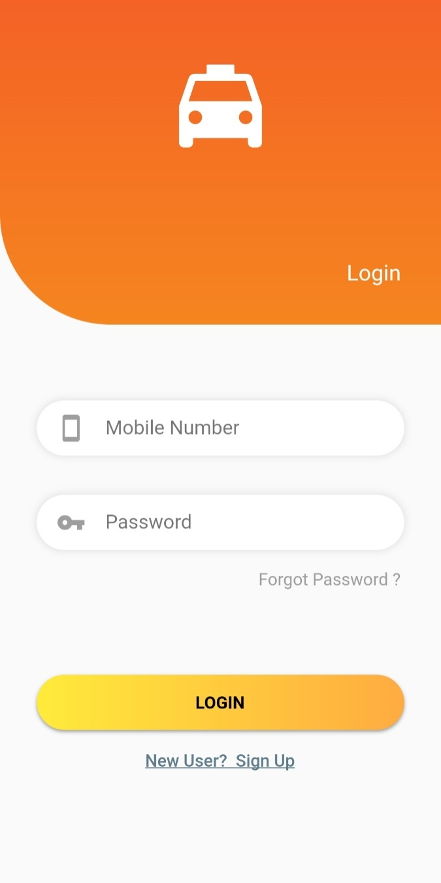

This Is The Login Page Where User Enter Mobile Number And Password To Login.

1. **Signup**

**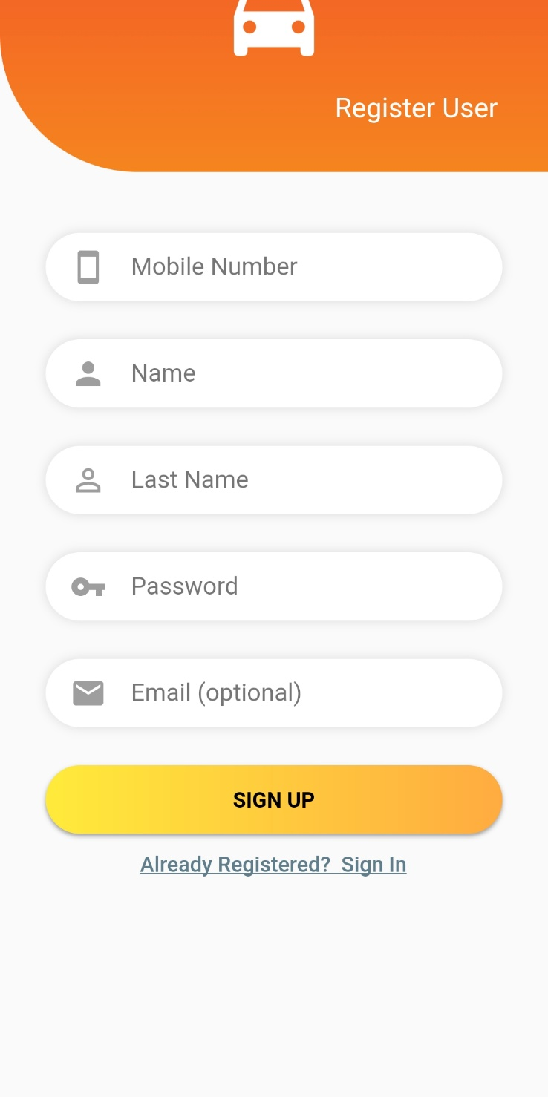**

This Is The Signup Page You Need To Fill These Details If You Are Signing-In-For The First Time.

1. **View User Details**

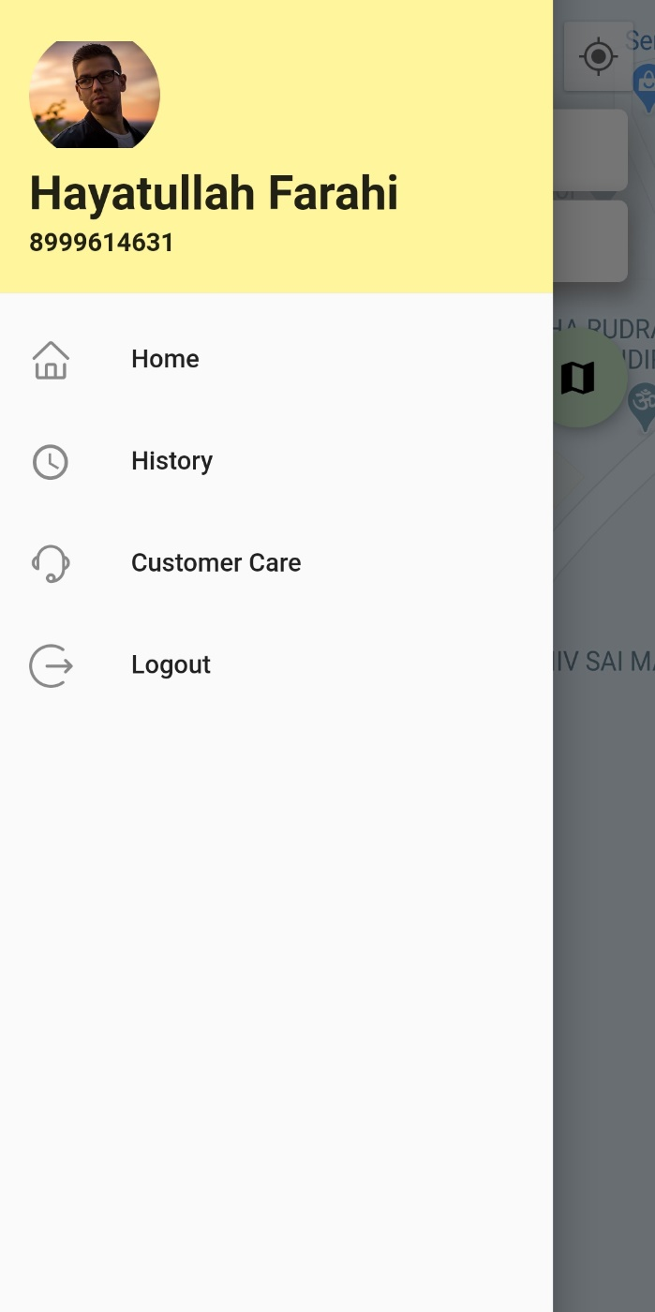

In This You Can Manage All the Home, History and Many More.

1. **Destination**

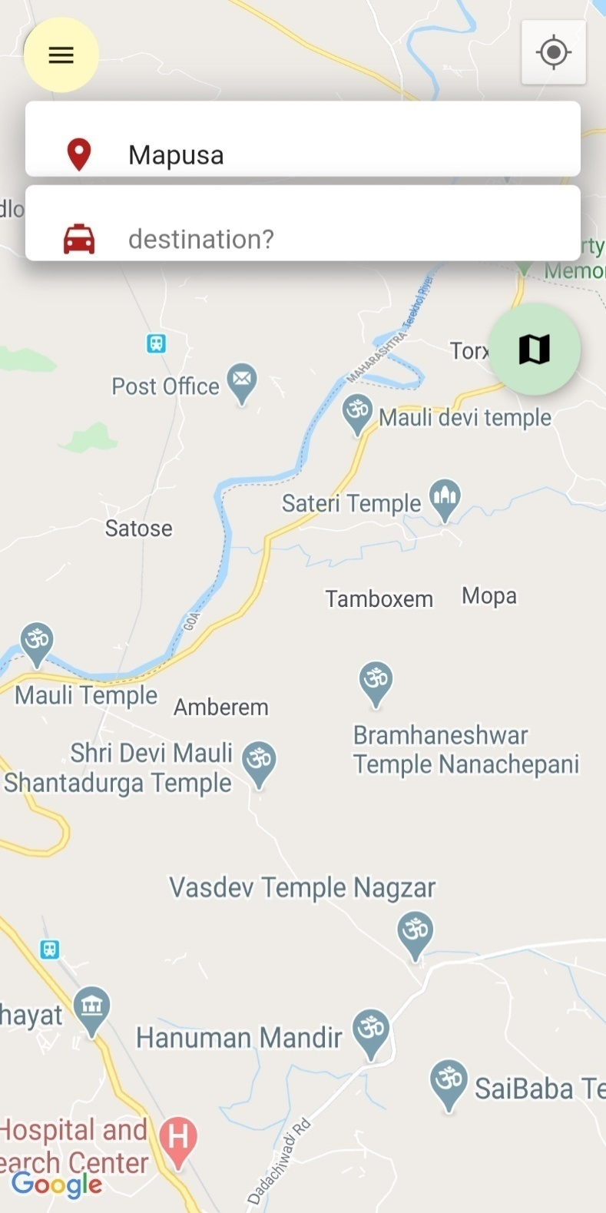

In This You Will Have To Choose A Pickup Location And Drop Location.

1. **Booking Cab**

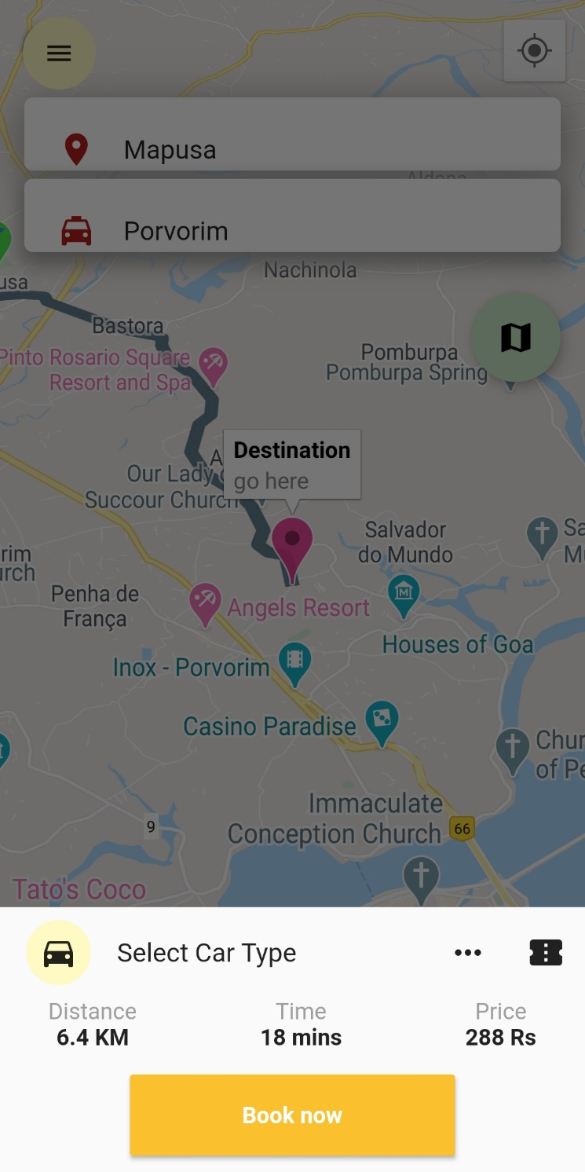

In This You Can Select A Car Type And Promo Code.

1. **Confirm Driver**

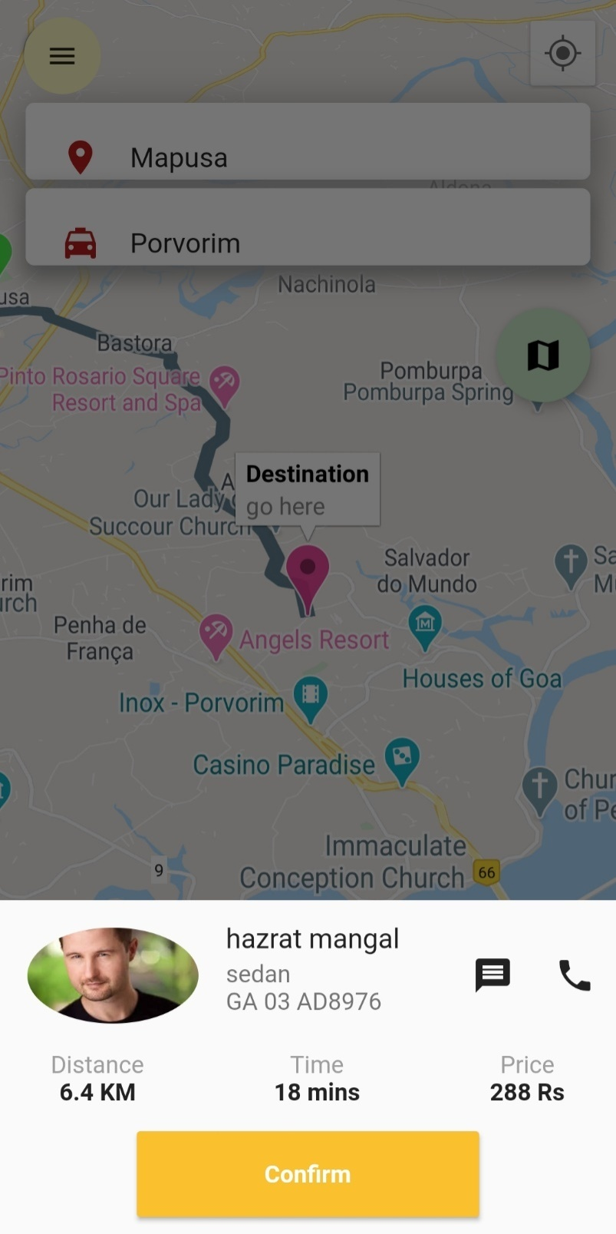

In This You Can Check driver details and Call driver

**7. View History**

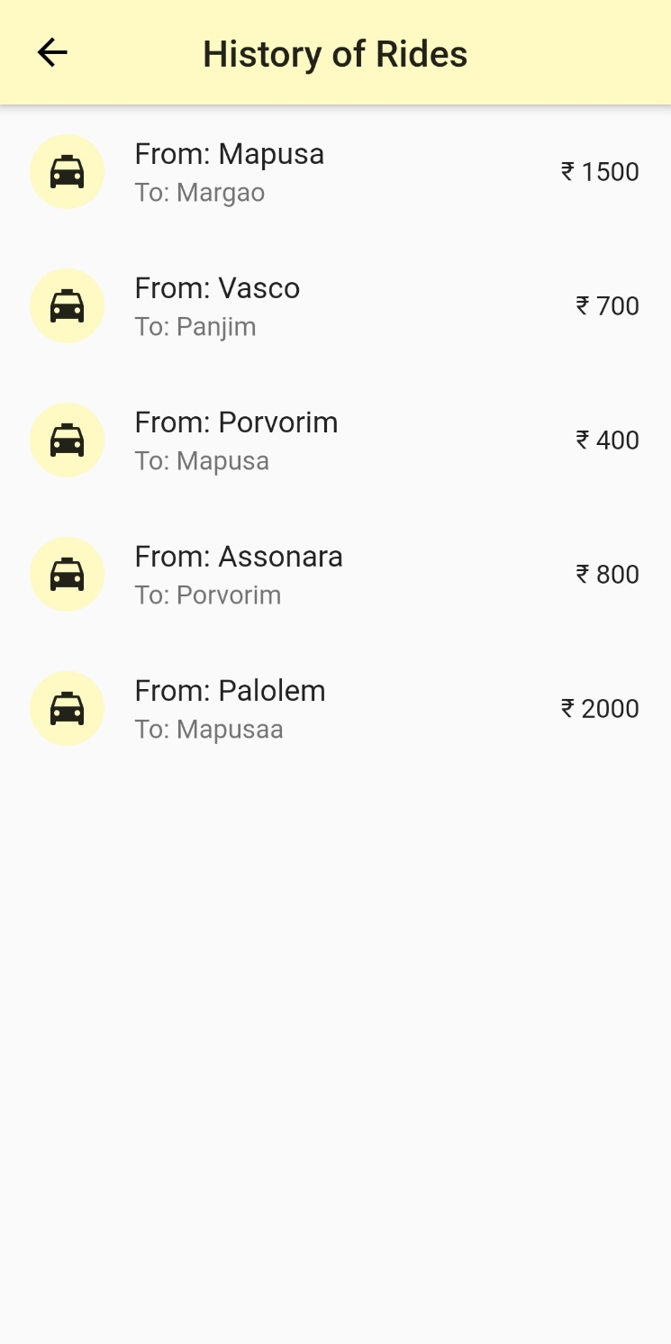

In This You Can View History Of Ride.

**8. Select Car**

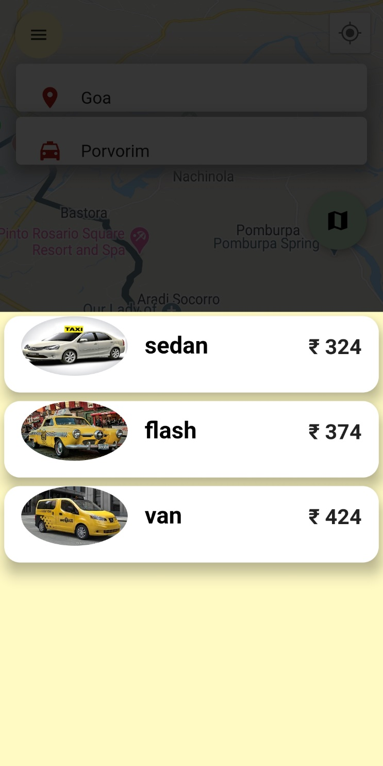

This Is A Car Option Where You Need To Choose Any One Of The Following Option.

**B) Driver**

**1. Login**

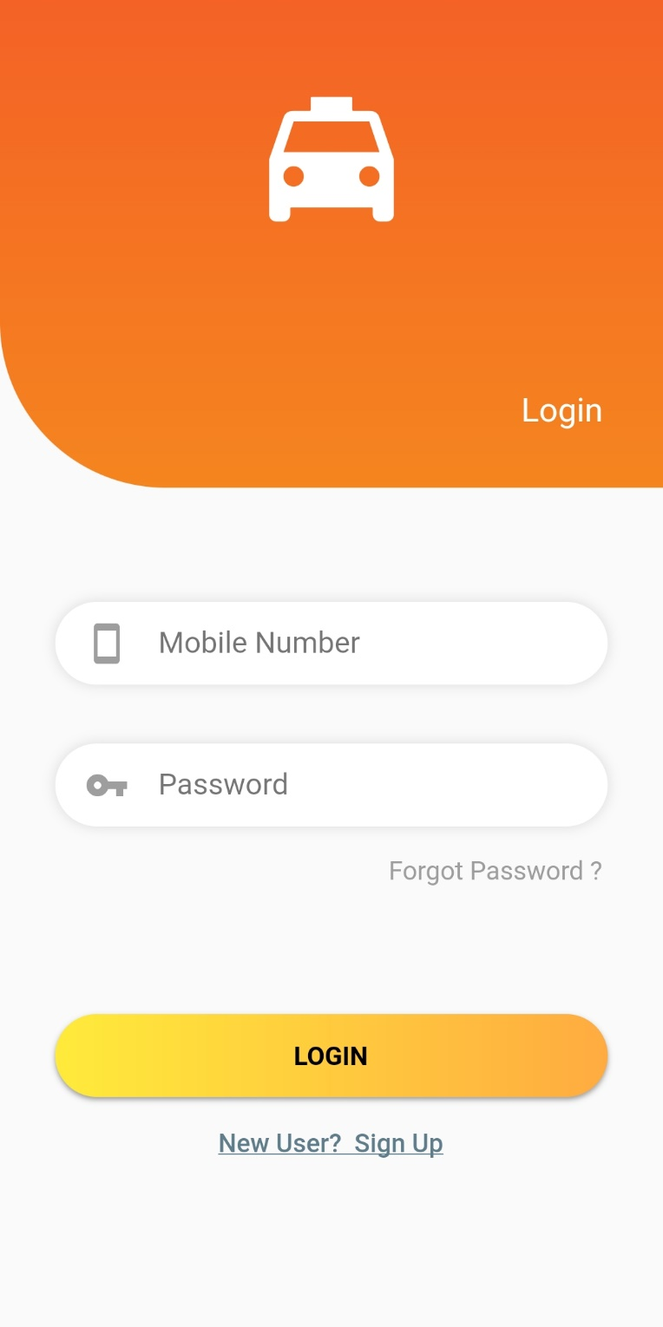

This Is The Login Page Where User Enter Mobile Number And Password To Login.

**2. Signup**

**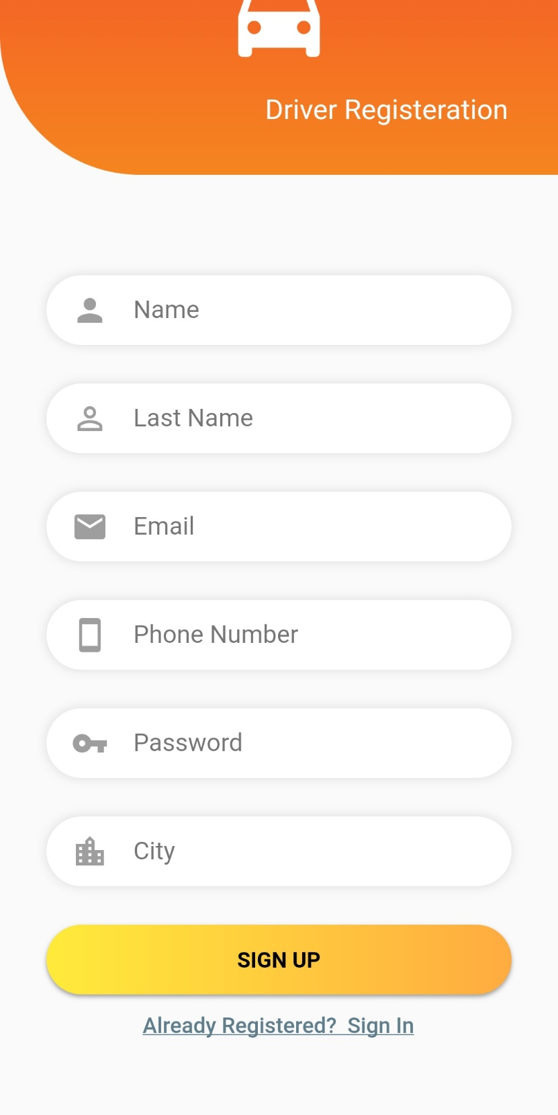**

This Is The Signup Page You Need To Fill These Details If You Are Signing-In-For The First Time.

**3. Driver Account**

**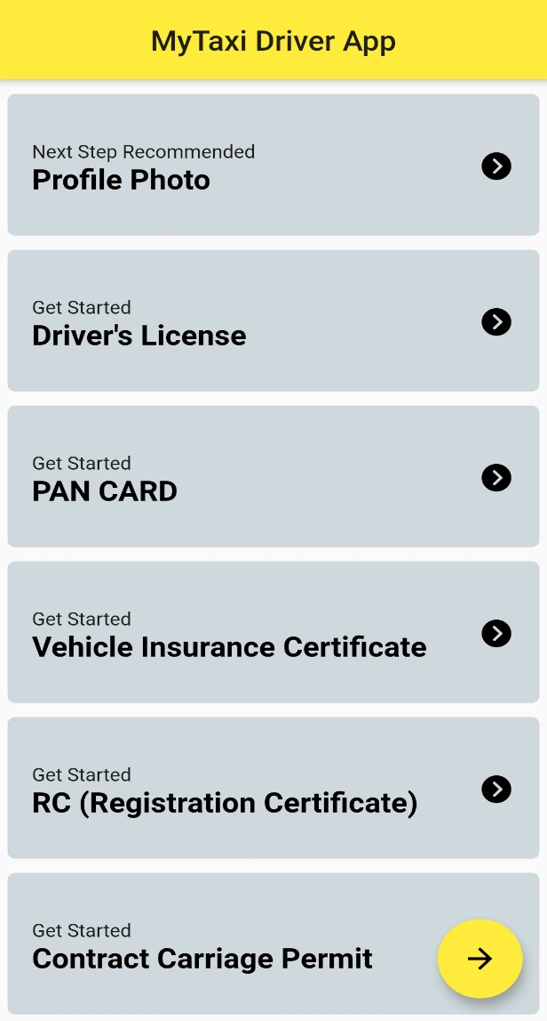**

In This Driver Can See All the Information and Also Modify His Account Information.

**4. View Driver Details**

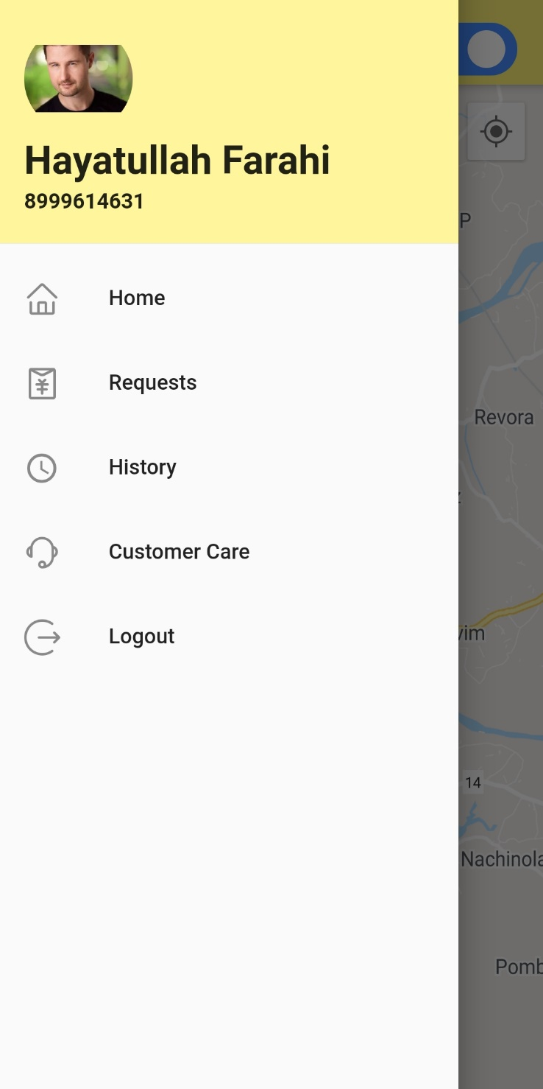  
In This You Can Manage All the Home, History, Request and Many More.

**5 Available/Unavailable button**

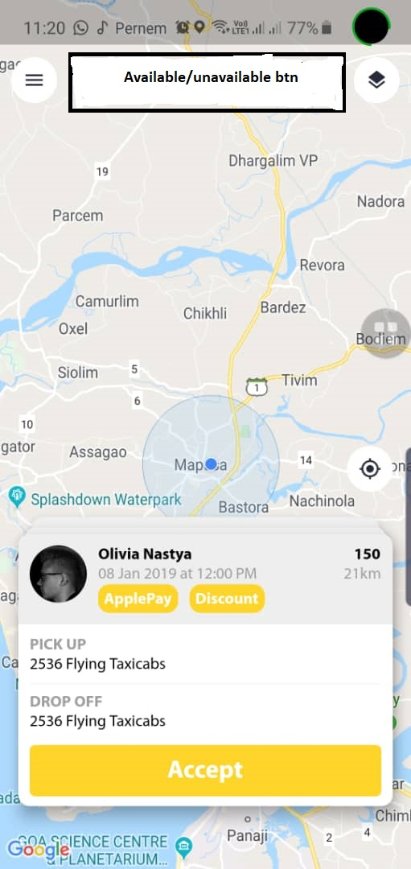

In This You Can Check Whether Customer Is Available Or Unavailable.

**6. History**

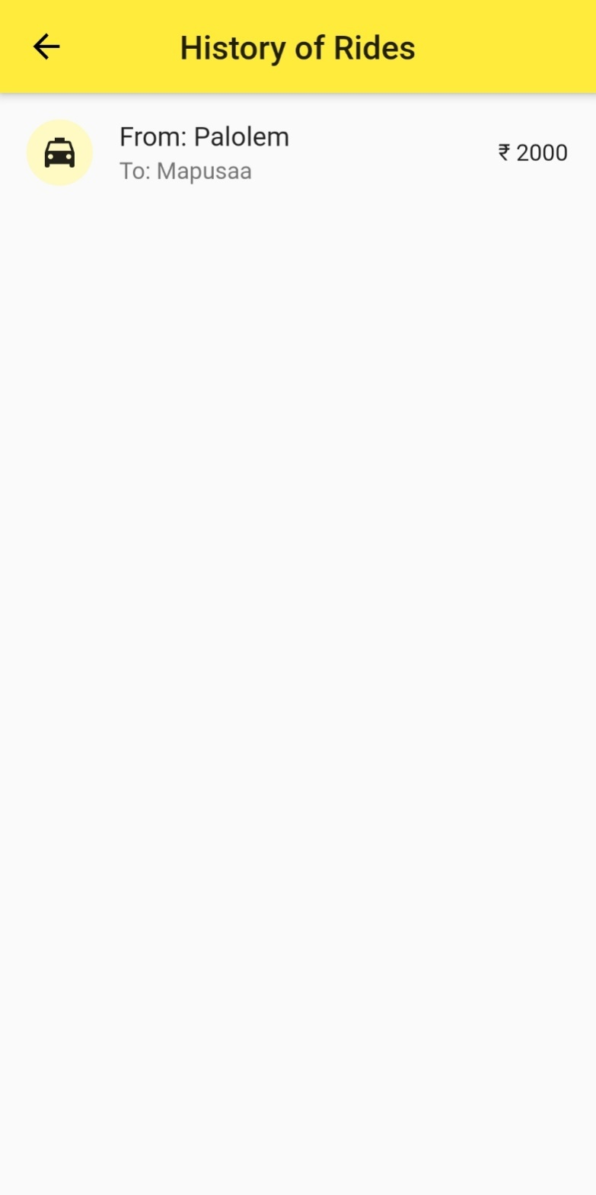

In This You Can View History Of Driver.

1. **Request**

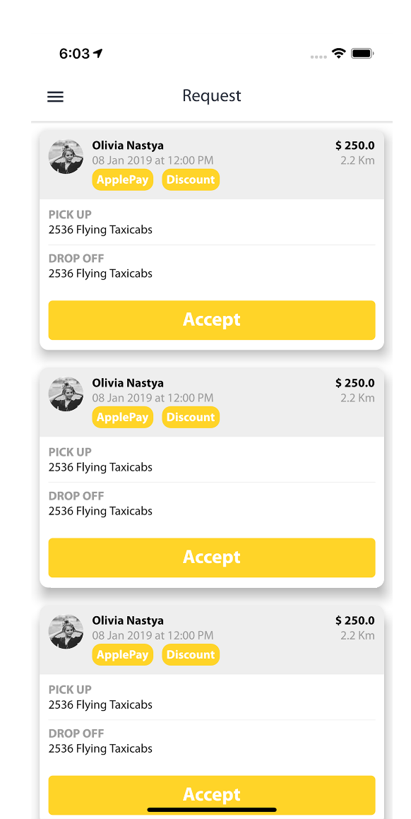

In This Driver Can Check The Request Of AllCustomer.

1. **Customer Care**

**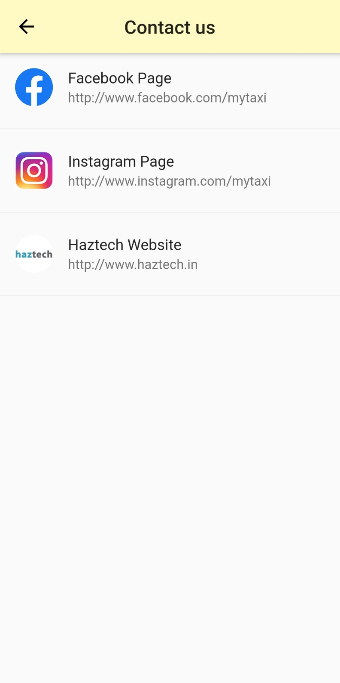**

In this screen customer can contact the company

**4.1. Backend Software Tools**

**Flutter**



**Flutter** is an [open-source](https://en.wikipedia.org/wiki/Open-source_software" \o "Open-source software)[UI](https://en.wikipedia.org/wiki/User_interface" \o "User interface)[software development kit](https://en.wikipedia.org/wiki/Software_development_kit" \o "Software development kit) created by [Google](https://en.wikipedia.org/wiki/Google" \o "Google). It is used to develop applications for [Android](https://en.wikipedia.org/wiki/Android_(operating_system)" \o "Android (operating system)), [iOS](https://en.wikipedia.org/wiki/IOS" \o "IOS), Windows, Mac, Linux, [Google Fuchsia](https://en.wikipedia.org/wiki/Google_Fuchsia" \o "Google Fuchsia) and the web.

The first version of Flutter was known as codename "Sky" and ran on the [Android](https://en.wikipedia.org/wiki/Android_(operating_system)" \o "Android (operating system)) operating system. It was unveiled at the 2015 [Dart](https://en.wikipedia.org/wiki/Dart_(programming_language)" \o "Dart (programming language)) developer summit, with the stated intent of being able to [render](https://en.wikipedia.org/wiki/Rendering_(computer_graphics)" \o "Rendering (computer graphics)) consistently at 120 [frames per second](https://en.wikipedia.org/wiki/Frame_rate" \o "Frame rate). During the keynote of Google Developer Days in Shanghai, Google announced Flutter Release Preview 2 which is the last big release before Flutter 1.0. On December 4, 2018, Flutter 1.0 was released at the Flutter Live event, denoting the first "stable" version of the Framework.On December 11, 2019, Flutter 1.12 was released at the Flutter Interactive event, it was announced that Flutter was the first UI platform designed for [ambient computing](https://en.wikipedia.org/w/index.php?title=Ambient_computing&action=edit&redlink=1" \o "Ambient computing (page does not exist)).

**Node js**



**Node.js** is an [open-source](mhtml:file://C:/Users/yash2/Documents/Node.js%20-%20Wikipedia.mhtml!https://en.m.wikipedia.org/wiki/Open-source_software" \o "Open-source software), [cross-platform](mhtml:file://C:/Users/yash2/Documents/Node.js%20-%20Wikipedia.mhtml!https://en.m.wikipedia.org/wiki/Cross-platform" \o "Cross-platform), [JavaScript](mhtml:file://C:/Users/yash2/Documents/Node.js%20-%20Wikipedia.mhtml!https://en.m.wikipedia.org/wiki/JavaScript" \o "JavaScript) runtime environment that executes JavaScript code outside of a browser. Node.js lets developers use JavaScript to write command line tools and for [server-side scripting](mhtml:file://C:/Users/yash2/Documents/Node.js%20-%20Wikipedia.mhtml!https://en.m.wikipedia.org/wiki/Server-side_scripting" \o "Server-side scripting)—running scripts server-side to produce [dynamic web page](mhtml:file://C:/Users/yash2/Documents/Node.js%20-%20Wikipedia.mhtml!https://en.m.wikipedia.org/wiki/Dynamic_web_page" \o "Dynamic web page) content before the page is sent to the user's web browser. Consequently, Node.js represents a "JavaScript everywhere" paradigm, unifying [web-application](mhtml:file://C:/Users/yash2/Documents/Node.js%20-%20Wikipedia.mhtml!https://en.m.wikipedia.org/wiki/Web_application" \o "Web application) development around a single programming language, rather than different languages for server- and client-side scripts.

Node.js was written initially by [Ryan Dahl](https://en.m.wikipedia.org/wiki/Ryan_Dahl" \o "Ryan Dahl) in 2009,about thirteen years after the introduction of the first server-side JavaScript environment, Netscape's Livewire Pro Web. The initial release supported only Linux and Mac OS X. Its development and maintenance was led by Dahl and later sponsored by [Joyent](https://en.m.wikipedia.org/wiki/Joyent" \o "Joyent).

**Express js**



**Express.js**, or simply **Express**, is a [web application framework](https://en.m.wikipedia.org/wiki/Web_application_framework" \o "Web application framework) for [Node.js](https://en.m.wikipedia.org/wiki/Node.js" \o "Node.js), released as [free and open-source software](https://en.m.wikipedia.org/wiki/Free_and_open-source_software" \o "Free and open-source software) under the [MIT License](https://en.m.wikipedia.org/wiki/MIT_License" \o "MIT License). It is designed for building [web applications](https://en.m.wikipedia.org/wiki/Web_application" \o "Web application) and [APIs](https://en.m.wikipedia.org/wiki/API" \o "API). It has been called the [de facto standard](https://en.m.wikipedia.org/wiki/De_facto_standard" \o "De facto standard) server framework for [Node.js](https://en.m.wikipedia.org/wiki/Node.js" \o "Node.js).

Express.js was developed by [TJ Holowaychuk](https://en.m.wikipedia.org/w/index.php?title=TJ_Holowaychuk&action=edit&redlink=1" \o "TJ Holowaychuk (page does not exist)), described it as a [Sinatra](https://en.m.wikipedia.org/wiki/Sinatra_(software)" \o "Sinatra (software))-inspired server meaning that it is relatively minimal with many features available as plugins. Express is the back-end component of the [MEAN stack](https://en.m.wikipedia.org/wiki/MEAN_(software_bundle)" \o "MEAN (software bundle)), together with the [Mongo DB](https://en.m.wikipedia.org/wiki/MongoDB" \o "MongoDB) database software and [AngularJS](https://en.m.wikipedia.org/wiki/AngularJS" \o "AngularJS) front-end framework.

Express.js is used by [Fox Sports](https://en.m.wikipedia.org/wiki/Fox_Sports" \o "Fox Sports), [PayPal](https://en.m.wikipedia.org/wiki/PayPal" \o "PayPal), [Uber](https://en.m.wikipedia.org/wiki/Uber" \o "Uber) and [IBM](https://en.m.wikipedia.org/wiki/IBM" \o "IBM).

In June 2014, rights to manage the project were acquired by [StrongLoop](https://en.m.wikipedia.org/wiki/StrongLoop" \o "StrongLoop). StrongLoop was acquired by [IBM](https://en.m.wikipedia.org/wiki/IBM" \o "IBM) in September 2015; in January 2016, IBM announced that it would place Express.js under the stewardship of the Node.js Foundation incubator.

**MySQL**



**MySQL** is an [open-source](https://en.wikipedia.org/wiki/Open-source_software" \o "Open-source software)[relational database management system](https://en.wikipedia.org/wiki/Relational_database_management_system" \o "Relational database management system) (RDBMS). Its name is a combination of "My", the name of co-founder [Michael Widenius](https://en.wikipedia.org/wiki/Michael_Widenius" \o "Michael Widenius)'s daughter, and "[SQL](https://en.wikipedia.org/wiki/SQL" \o "SQL)", the abbreviation for [Structured Query Language](https://en.wikipedia.org/wiki/Structured_Query_Language" \o "Structured Query Language).

MySQL is [free and open-source software](https://en.wikipedia.org/wiki/Free_and_open-source_software" \o "Free and open-source software) under the terms of the [GNU General Public License](https://en.wikipedia.org/wiki/GNU_General_Public_License" \o "GNU General Public License), and is also available under a variety of [proprietary](https://en.wikipedia.org/wiki/Proprietary_software" \o "Proprietary software) licenses. MySQL was owned and sponsored by the [Swedish](https://en.wikipedia.org/wiki/Sweden" \o "Sweden) company [MySQL AB](https://en.wikipedia.org/wiki/MySQL_AB" \o "MySQL AB), which was bought by [Sun Microsystems](https://en.wikipedia.org/wiki/Sun_Microsystems" \o "Sun Microsystems) (now [Oracle Corporation](https://en.wikipedia.org/wiki/Oracle_Corporation" \o "Oracle Corporation)). In 2010, when Oracle acquired Sun, Widenius [forked](https://en.wikipedia.org/wiki/Fork_(software_development)" \o "Fork (software development)) the [open-source](https://en.wikipedia.org/wiki/Open-source" \o "Open-source) MySQL project to create [MariaDB](https://en.wikipedia.org/wiki/MariaDB" \o "MariaDB).

MySQL is a component of the [LAMP](https://en.wikipedia.org/wiki/LAMP_(software_bundle)" \o "LAMP (software bundle))[web application](https://en.wikipedia.org/wiki/Web_application" \o "Web application)[software stack](https://en.wikipedia.org/wiki/Software_stack" \o "Software stack) (and [others](https://en.wikipedia.org/wiki/List_of_AMP_packages" \o "List of AMP packages)), which is an acronym for [Linux](https://en.wikipedia.org/wiki/Linux" \o "Linux), [Apache](https://en.wikipedia.org/wiki/Apache_HTTP_Server" \o "Apache HTTP Server), MySQL, [Perl](https://en.wikipedia.org/wiki/Perl" \o "Perl)/[PHP](https://en.wikipedia.org/wiki/PHP" \o "PHP)/[Python](https://en.wikipedia.org/wiki/Python_(programming_language)" \o "Python (programming language)). MySQL is used by many database-driven web applications, including [Drupal](https://en.wikipedia.org/wiki/Drupal" \o "Drupal), [Joomla](https://en.wikipedia.org/wiki/Joomla" \o "Joomla), [phpBB](https://en.wikipedia.org/wiki/PhpBB" \o "PhpBB), and [WordPress](https://en.wikipedia.org/wiki/WordPress" \o "WordPress).

**4.2. Frontier Software Tools**

**Android Studio**



**Android Studio**is the official integrated development environment (IDE) for developing for the Android platform. It was announced on May 16, 2013 at the Google I/O conference. Android Studio is freely available under the Apache License 2.0.

Android Studio was in early access preview stage starting from version 0.1 in May 2013, then entered beta stage staring from version 0.8 which was released in June 2014, the first stable build was released in December 2014, starting from version 1.0.

Based on [JetBrains](https://en.wikipedia.org/wiki/JetBrains" \o "JetBrains) IntelliJ IDEA software, Android Studio is designed specifically for Android development. It is software for download on Windows, Mac OS X and Linux, and replaced Eclipse Android Development Tools (ADT) as Google’s primary IDE for native Android application development.

**Visual Studio Code**



**Visual Studio Code** is a [source-code editor](https://en.wikipedia.org/wiki/Source-code_editor" \o "Source-code editor) developed by [Microsoft](https://en.wikipedia.org/wiki/Microsoft" \o "Microsoft) for [Windows](https://en.wikipedia.org/wiki/Windows" \o "Windows), [Linux](https://en.wikipedia.org/wiki/Linux" \o "Linux) and [macOS](https://en.wikipedia.org/wiki/MacOS" \o "MacOS). It includes support for [debugging](https://en.wikipedia.org/wiki/Debugging" \o "Debugging), embedded [Git](https://en.wikipedia.org/wiki/Git" \o "Git) control and [GitHub](https://en.wikipedia.org/wiki/GitHub" \o "GitHub), [syntax highlighting](https://en.wikipedia.org/wiki/Syntax_highlighting" \o "Syntax highlighting), [intelligent code completion](https://en.wikipedia.org/wiki/Intelligent_code_completion" \o "Intelligent code completion), [snippets](https://en.wikipedia.org/wiki/Snippet_(programming)" \o "Snippet (programming)), and [code refactoring](https://en.wikipedia.org/wiki/Code_refactoring" \o "Code refactoring). It is highly customizable, allowing users to change the [theme](https://en.wikipedia.org/wiki/Theme_(computing)" \o "Theme (computing)), [keyboard shortcuts](https://en.wikipedia.org/wiki/Keyboard_shortcut" \o "Keyboard shortcut), preferences, and install [extensions](https://en.wikipedia.org/wiki/Plug-in_(computing)" \o "Plug-in (computing)) that add additional functionality. The source code is [free and open source](https://en.wikipedia.org/wiki/Free_and_open_source" \o "Free and open source) and released under the permissive [MIT License](https://en.wikipedia.org/wiki/MIT_License" \o "MIT License). The compiled binaries are [freeware](https://en.wikipedia.org/wiki/Freeware" \o "Freeware) and free for private or commercial use.

Visual Studio Code is based on [Electron](https://en.wikipedia.org/wiki/Electron_(software_framework)" \o "Electron (software framework)), a framework which is used to develop [Node.js](https://en.wikipedia.org/wiki/Node.js" \o "Node.js) applications for the desktop running on the [Blink layout engine](https://en.wikipedia.org/wiki/Blink_layout_engine" \o "Blink layout engine). Although it uses the Electron framework, the software does not use [Atom](https://en.wikipedia.org/wiki/Atom_(text_editor)" \o "Atom (text editor)) and instead employs the same editor component (codenamed "Monaco") used in [Azure DevOps](https://en.wikipedia.org/wiki/Azure_DevOps_Server" \o "Azure DevOps Server) (formerly called Visual Studio Online and Visual Studio Team Services).

**MySQL Workbench**



**MySQL Workbench** is a visual [database design](mhtml:file://C:/Users/yash2/Documents/MySQL%20Workbench%20-%20Wikipedia.html.mhtml!https://en.m.wikipedia.org/wiki/Database_design" \o "Database design) tool that integrates [SQL](mhtml:file://C:/Users/yash2/Documents/MySQL%20Workbench%20-%20Wikipedia.html.mhtml!https://en.m.wikipedia.org/wiki/SQL" \o "SQL)[development](mhtml:file://C:/Users/yash2/Documents/MySQL%20Workbench%20-%20Wikipedia.html.mhtml!https://en.m.wikipedia.org/wiki/Software_development" \o "Software development), [administration](mhtml:file://C:/Users/yash2/Documents/MySQL%20Workbench%20-%20Wikipedia.html.mhtml!https://en.m.wikipedia.org/wiki/Database_administration" \o "Database administration), [database design](mhtml:file://C:/Users/yash2/Documents/MySQL%20Workbench%20-%20Wikipedia.html.mhtml!https://en.m.wikipedia.org/wiki/Database_design" \o "Database design), creation and maintenance into a single [integrated development environment](mhtml:file://C:/Users/yash2/Documents/MySQL%20Workbench%20-%20Wikipedia.html.mhtml!https://en.m.wikipedia.org/wiki/Integrated_development_environment" \o "Integrated development environment) for the [MySQL](mhtml:file://C:/Users/yash2/Documents/MySQL%20Workbench%20-%20Wikipedia.html.mhtml!https://en.m.wikipedia.org/wiki/MySQL" \o "MySQL) database system. It is the successor to DB Designer 4 from fabFORCE.net, and replaces the previous package of software, [MySQL GUI Tools Bundle](mhtml:file://C:/Users/yash2/Documents/MySQL%20Workbench%20-%20Wikipedia.html.mhtml!https://en.m.wikipedia.org/wiki/MySQL_Workbench" \l "MySQL_GUI_Tools_Bundle).

The first preview version of MySQL Workbench was released in September 2005, and was not included in the [MySQL GUI Tools Bundle](https://en.m.wikipedia.org/wiki/MySQL_Workbench" \l "MySQL_GUI_Tools_Bundle). Development was started again in 2007 and MySQL Workbench was set to become the MySQL GUI flagship product.

Version numbering was started at 5.0 to emphasise that MySQL Workbench was developed as the successor to DBDesigner4.

**4.2. Middle and Auxiliary Tools**

**StarUML**



**StarUML** is a UML tool by MKLab. The software was licensed under a modification version of GNU GPL until 2014, when a rewritten version 2.0.0 was released for beta testing under a proprietary license.

After being abandoned for some time, the project had a revival to move from Delphi to Java/Eclipse and then stopped again. In 2014, a rewritten version was released as proprietary software. However, the open source version’s community is still active.

The stated goal of the project was to replace larger, commercial applications such as Rational Rose and Borland Together.

StarUML supports most of the diagram types specified in UML 2.0. It is currently missing timing and interaction overview diagrams.

Currently the newest version of StarUML by the original authors is available for download under the handle “StarUML 2”. The public beta is available, although not under the GPL license. Final price and new license type yet remain unknown. This version has been completely rewritten from scratch and includes among many features: support for extensions, OS X compatibility and a new graphical user interface.

**AAA Logo**



**AAA Logo**is a tool that allows the professional creation of specific logos for the web. It stands out due to its simplicity because it includes all the templates and objects that you might need when designing a logo. Furthermore, it can also be used to design other elements such as buttons, banners, and icons.

Logos are graphical elements made up of letters and abbreviations that represent a company, product or brand. It can be said that it is a distinctive sign of quality, furthermore, it also **adds identity to the element it represents**. To create a good logo we require a studied design and knowledge of some professional graphical editing software. But, if you're very creative you can obtain a more than acceptable result with an application like **AAA Logo**.

**5. Future Enhancement**

* Online Taxi Booking.
* Cross Platform Mobile App
* Select Your favourite cab
* Use coupons to get discount

**6. References**

* [www.github.com](http://www.github.com)
* [www.youtube.com](http://www.youtube.com)
* [www.developer.android.com](http://www.developer.android.com)
* www.flutter.dev/docs